**A certificate of deposit (CD)**

A certificate of deposit (CD) is a type of savings account offered by banks and credit unions in the United States. CDs typically pay a higher interest rate than a regular savings account, but in exchange, the customer agrees to leave the money on deposit for a specific period of time, known as the term.

Key Features of CDs

Fixed Interest Rates

CDs offer fixed interest rates that are higher than those of regular savings accounts. The interest rate on a CD is determined by the term length and the amount deposited, with longer terms and larger deposits generally earning higher rates.

Specific Maturity Dates

CDs have a defined maturity date, which is the date when the CD term ends and the money can be withdrawn without penalty. Customers must leave their money on deposit until the maturity date to avoid early withdrawal penalties.

Early Withdrawal Penalties

If a customer withdraws money from a CD before the maturity date, they will typically incur an early withdrawal penalty. This penalty can significantly reduce the interest earned on the CD.

Minimum Deposit Requirements

CDs often have minimum deposit requirements, which can range from $0 to $10,000 for standard CDs. "Jumbo CDs" typically require a minimum deposit of $100,000 or more.

Federal Deposit Insurance

Funds held in CDs are insured by the Federal Deposit Insurance Corporation (FDIC) for banks and the National Credit Union Administration (NCUA) for credit unions, up to the standard coverage limit of $250,000 per depositor.

Benefits and Drawbacks of CDs

Benefits

* Rates are typically higher than savings or money market accounts
* Guaranteed, predictable rate of return is less risky than volatile stocks and bonds
* Federally insured if opened with an FDIC- or NCUA-insured bank or credit union
* Can help you avoid spending temptations since withdrawing funds early triggers a penalty

Drawbacks

* Penalties for withdrawing funds early
* Typically earns less than stocks and bonds over time
* Fixed rate could cost you if interest rates rise during the term
* Inflation can eat away at the value of money locked in at a fixed rate

Strategies for Using CDs

CD Laddering

CD laddering is a strategy where an investor spreads their money across multiple CDs with different maturity dates. This can help mitigate the liquidity issue by staggering the availability of the funds.

Comparing CD Rates

Customers should compare CD rates across multiple banks and credit unions to ensure they are getting the best possible return on their investment. By understanding the key features, benefits, and drawbacks of CDs, as well as common strategies for using them.

**13 Leading CDs Pay 5.75% to 6.00% APY for 6-17 Months**

Term length of the highest-paying nationally available CDs. Rates current as of Oct. 4, 2023.

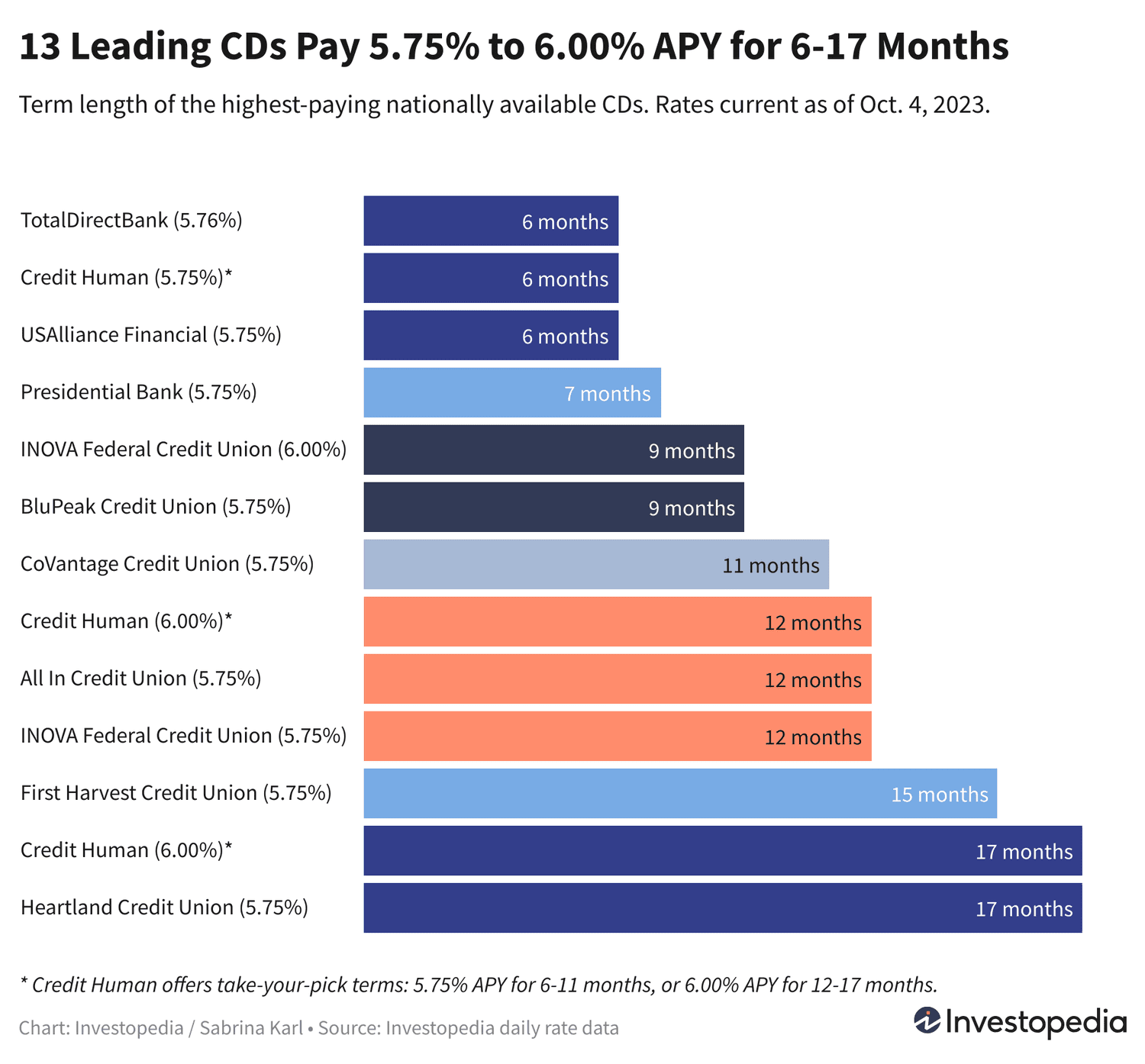

**The Fed's Role in CD Rates**

* In December 2008, the Fed reduced the federal funds rate to near-zero as a stimulus measure during the Great Recession. This caused CD rates, along with other deposit rates, to plummet.
* The Fed kept rates at essentially zero for seven years until 2015, severely depressing CD yields during that period.
* In 2020, the Fed again cut rates to zero in response to the economic impact of the COVID-19 pandemic, once more suppressing CD rates.
* Starting in 2022, the Fed began aggressively raising interest rates to combat record-high inflation. This has caused average CD rates to triple or quadruple compared to 2021 levels.

So in summary, the Fed's monetary policy actions, particularly its interest rate decisions, have had a direct and significant impact on the yields available on CDs in the US banking system over the past 15 years. CD rates closely track the federal funds rate, rising when the Fed raises rates and falling when the Fed cuts them.

**Money market accounts (MMAs)**

They are a type of deposit account offered by banks, credit unions, and other financial institutions in the United States. They are designed to provide customers with a safe and liquid place to store their money while earning a higher interest rate compared to a traditional savings account. MMAs combine features of both savings and checking accounts, offering the higher yields of savings accounts along with some check-writing and debit card access like checking accounts. This hybrid nature makes them a popular choice for short-term savings and cash management.

Key Features of Money Market Accounts

1. **Higher Interest Rates**: MMAs typically offer interest rates that are higher than those of regular savings accounts, though the spread has narrowed in recent years as interest rates have risen across the board. The higher yields are achieved by investing the pooled deposits in short-term, low-risk securities like Treasury bills, certificates of deposit (CDs), and commercial paper.
2. **Liquidity and Accessibility**: MMAs allow customers to access their funds relatively easily, often through the use of checks, debit cards, and electronic transfers. However, there are usually limits on the number of transactions per month (typically 6) due to federal regulations.
3. **FDIC/NCUA Insurance**: Like savings accounts, MMAs are insured by the Federal Deposit Insurance Corporation (FDIC) for banks or the National Credit Union Administration (NCUA) for credit unions, up to $250,000 per depositor, per institution. This provides a high degree of safety for the deposited funds.
4. **Minimum Balance Requirements**: MMAs often require a higher minimum balance compared to regular savings accounts, typically ranging from $1,000 to $10,000 or more. Failing to maintain the minimum balance may result in fees or a lower interest rate.
5. **Fees and Charges**: MMAs may come with various fees, such as monthly maintenance fees, excess withdrawal fees, and fees for falling below the minimum balance. It's important to review the fee structure when selecting an MMA.

Differences from Other Account Types

1. **Checking Accounts**: While MMAs provide some check-writing and debit card access, they have more restrictions on transactions per month compared to traditional checking accounts.
2. **Savings Accounts**: MMAs generally offer higher interest rates than regular savings accounts but may have higher minimum balance requirements.
3. **Money Market Mutual Funds**: MMAs are deposit accounts insured by the FDIC/NCUA, while money market mutual funds are investment products not insured by the government.

Uses and Benefits of Money Market Accounts

MMAs are well-suited for short-term savings goals, emergency funds, and other liquid cash needs. The higher interest rates can help grow your savings faster than a traditional savings account, while the FDIC/NCUA insurance and accessibility of the funds make them a safe and convenient option. Some common use cases for MMAs include:

* **Short-Term Savings**: Saving for a down payment on a house, a vacation, or a large purchase in the near future.
* **Emergency Fund**: Storing easily accessible cash for unexpected expenses or financial emergencies.
* **Temporary Parking of Funds**: Holding cash temporarily before investing in other financial products.

**Individual Retirement Accounts (IRAs)**

An Individual Retirement Account (IRA) is a tax-advantaged investment account designed to help individuals save for retirement. IRAs offer tax benefits that can help your retirement savings grow faster compared to regular taxable investment accounts.

Types of IRAs

There are several different types of IRAs, each with its own set of rules and tax implications:

1. **Traditional IRAs**:
   * Contributions may be tax-deductible, depending on your income and participation in an employer-sponsored retirement plan.
   * Earnings grow tax-deferred, and withdrawals are taxed as ordinary income.
   * You must begin taking required minimum distributions (RMDs) at age 73.
2. **Roth IRAs**:
   * Contributions are made with after-tax dollars, but qualified withdrawals are tax-free.
   * Income limits apply for eligibility to contribute.
   * No RMDs during the account owner's lifetime.
3. **SEP IRAs (Simplified Employee Pension)**:
   * Designed for self-employed individuals and small business owners.
   * Employers can contribute up to 25% of an employee's compensation, up to an annual limit.
   * Contributions are tax-deductible, and earnings grow tax-deferred.
4. **SIMPLE IRAs (Savings Incentive Match Plan for Employees)**:
   * Intended for small businesses with 100 or fewer employees.
   * Both employers and employees can contribute.
   * Contributions are tax-deductible, and earnings grow tax-deferred.

Contribution Limits

The annual contribution limits for IRAs are as follows:

* Traditional and Roth IRAs: $6,500 for 2023, $7,000 for 2024 (plus an additional $1,000 for those aged 50 and older).
* SEP IRAs: The lesser of 25% of compensation or $66,000 for 2023, $69,000 for 2024.
* SIMPLE IRAs: $15,500 for 2023, $16,000 for 2024 (plus an additional $3,500 for those aged 50 and older).

|  |  |  |  |
| --- | --- | --- | --- |
| Feature | Certificate of Deposit (CD) | Money Market Account (MMA) | Individual Retirement Account (IRA) |
| Account Type | Savings account with fixed term and rate | Savings account with variable, tiered interest rates | Retirement savings account with tax advantages |
| Access to Funds | Limited access until maturity, early withdrawal penalties | More accessible than CDs, limited monthly transactions | Limited access before age 59 1/2, with some exceptions |
| Interest Rates | Higher than regular savings, fixed for term | Competitive with CDs, variable and tiered | Depends on investments, not fixed |
| Minimum Deposit | Typically, $0 to $10,000, "jumbo CDs" $100,000+ | Typically, $0 to $2,500 | No minimum, but annual contribution limits apply |
| FDIC/NCUA Insurance | Yes, up to $250,000 per depositor | Yes, up to $250,000 per depositor | No direct insurance, but investments are protected |
| Tax Treatment | Interest is taxable as ordinary income | Interest is taxable as ordinary income | Tax-deferred (traditional) or tax-free (Roth) growth and withdrawals |
| Primary Purpose | Short-term savings, stable returns | Accessible savings, modest returns | Long-term retirement savings, tax advantages |